Grade 7 Accelerated · Unit 4 · Lesson 5  Evaluating Expressions with Radicals  Independent Set 4.05 ANSWER KEY | Name  Date  Period

Six questions, on your own, in silence. Show the step that does the work.
1. 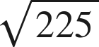
15

2. 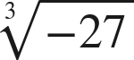
−3
An odd root keeps the sign.

3. 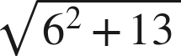
7
36 + 13 = 49.

4. 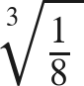

5. 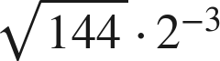
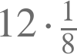.

6. 

